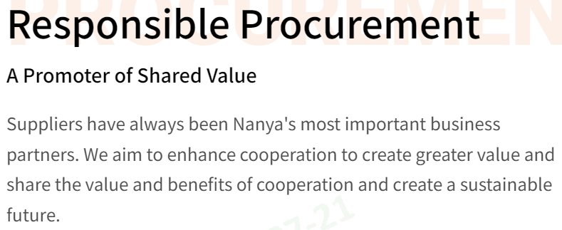
NT$125.78 million
From 2019 to 2025, the refund for blue-collar migrant workers regarding items such as brokerage fees, transportation fees, service fees, medical examination fees

211 smelters
Among suppliers of 3TG metals (tin, tantalum, tungsten, gold), cobalt, and mica, the number of smelters recognized by the RMI in supplier reports

39 smelters
Among suppliers of strategic metals subject to international import/export restrictions (aluminum, copper, nickel, and zinc), the number of smelters recognized by the RMI in supplier reports

頁眉
Sustainable Supply Chain Management | Improve the sustainability of supply chains | Responsible Mineral Sourcing Management

Strategy and Performance of Material Topics
2025 Performance
Sustainable Supply Chain Management
- Use 100% conflict-free minerals and responsibly procured minerals (Goal: 100%)
- Completion of SAQ by significant suppliers 100% (Goal: 100%)
- 100% completion rate of deficiency improvements by suppliers with high sustainability risk in audits (Goal: 100%)
- 100% of suppliers signing Supplier Code of Conduct (Goal: 100%)
- 100% completion of audits and guidance for significant suppliers (Goal: 100%)
- Implement at least 2 supplier sustainability guidance projects (Goal: 2 cases)
2026 Goal
Sustainable Supply Chain Management
- Use 100% conflict-free minerals and responsibly procured minerals
- Completion of SAQ by significant suppliers 100%
- 100% completion rate of deficiency improvements by suppliers with high sustainability risk in audits
- 100% of suppliers signing Supplier Code of Conduct
- 100% completion of audits and guidance for significant suppliers
- Implement at least 2 supplier sustainability guidance projects
Strategy
Sustainable Supply Chain Management
- Conflict-free Metals and Responsible Minerals Sourcing Management: Nanya Technology ensures that all products are free from conflict minerals
- Supply Chain Risk Management: Suppliers undergo regular evaluations covering quality, delivery, service, cost, technology, and sustainable management

Sustainable Supply Chain Management

Sustainable Supply Chain Management Strategies
Nanya Technology's screening criteria for direct production material suppliers mandate not only ISO 9001 and ISO 14001 third-party verification but also rigorous internal evaluations. Utilizing an electronic supplier evaluation management system, we assess suppliers across six key aspects: quality, delivery, service, cost, technology, and sustainability. Among the evaluation criteria, the sustainability management indicator (sustainability) accounts for 19% of the total score to ensure suppliers meet the Company's sustainable supplier management requirements. Once suppliers are approved, Nanya Technology further verifies the implementation status of sustainable supplier management through document reviews and on-site audits.
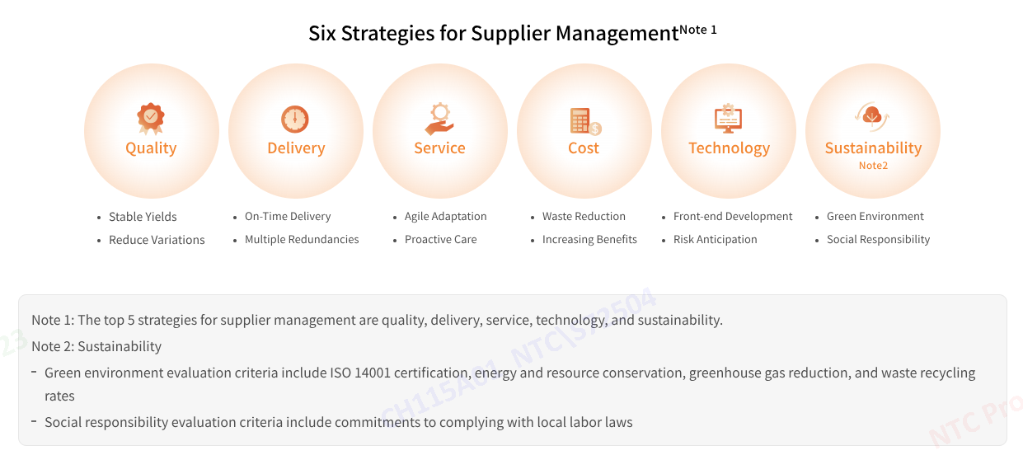

Sustainable Supply Chain Management Process
Nanya Technology has established a comprehensive supply chain management procedure. We ensure our suppliers meet our standards and requirements through a cycle involving five key processes: sustainability regulation, active risk assessment, sustainability risk assessment questionnaire, sustainability audit/improvement guidance, and supplier capacity building. Through risk assessment and audits, we monitor the risk level of our supply chain and guide suppliers to improve and build capacity, gradually strengthening the sustainability performance of the supply chain.
Sustainability Regulation | Total of 355 suppliers have completed signing the Supplier Code of Conduct with a rate of 100%.  - Suppliers need to adhere and sign the Nanya Technology Supplier Code of Conduct  - 100% signing rate of the Responsible Mining Policy and Conflict-Free Metals Declaration by suppliers of 3TG + cobalt-related materials
Active Risk Assessment | Complete 100% supplier assessment  - Investigate suppliers' locations, procurement amount, product categories, and ESG compliance status to conduct initial risk assessment. This allows us to actively identify and mitigate supply chain risks.
Sustainability Risk Assessment Questionnaire | Screened the 20 suppliers as the high-risk suppliers.  - To ensure the effective implementation of supplier sustainability practices. After reviewing the risks exposed through the self assessment, our procurement and sus tainability teams will further identify suppliers with higher ESG risks and conduct relevant procurement audits and guidance measures.
Sustainability Audit/Guidance and Improvement | 100% have been completed  - Documentary audit  - On-site audit  - Improvement Guidance
Capacity Building | No suppliers were eliminated in 2025.  - Reward: In addition to awards, excellent suppliers are consid ered favorably in future selection processes, increasing their opportunities for partnerships  - Elimination: If a supplier fails to improve in two years, we will gradually eliminate them from our supplier pool through reduced orders, order reassignment, or cessation of cooperation  - Capacity Building: Collaborating with suppliers to promote ESG-related projects Elimination mechanisms: If a supplier cannot complete improvements within the two years, it will be eliminated by reducing, transferring orders, or cease cooperation

Supply Chain Sustainability Projects
To address evolving sustainability trends and updates, Nanya Technology enhances suppliers' sustainability as well as their awareness and capacity in sustainable development through seminars and project-based guidance.
 | Three Zeros Human Rights Initiative Advancement Project | Product carbon footprint inventory
Project Period | 2022~2030 | - Conducted baseline establishment from 2023 to 2024  - From 2024 to 2025, a total of 15 product carbon footprint inventories and ISO 14067 verification were completed across 10 supply chain partners
Capacity Building Goals | We promote the "Three Zeros Human Rights Initiative" among our significant suppliers, aiming for zero violations in terms of humane treatment, forced labor, and discrimination | Promoting carbon footprint inventory among raw material suppliers and packaging/testing contractors
Estimated Benefit | We strive to strengthen human rights protection, mitigate human exploitation, establish a supportive workplace environment, and eliminate sweatshops | - Aligning with global climate change initiatives  - Reducing the Company's product carbon footprint  - Achieving SBT certification and reaching targets by 2030

Improve the Sustainability of Supply Chains
Sustainable Development Mutual Benefit Initiative
As the era of carbon pricing approaches, Nanya Technology continues to advance low-carbon transformation across its supply chain while actively investing in the in-house development of 10nm-class advanced process technologies. Through industry-academic technological collaboration, cross-sector capability sharing, and the implementation of digital tools, we empower our suppliers and jointly strengthen the momentum for low-carbon transformation, hoping to build a resilient, competitive, and sustainable industry chain. Therefore, in 2023, Nanya Technology collaborated with 10 suppliers to join the DRAM Supply Chain Low-Carbon Transformation Program led by the Industrial Development Administration, Ministry of Economic Affairs. This two-year program allowed Nanya Technology to join forces with its supply chain partners as well as the Industrial Technology Research Institute and National Taiwan University of Science and Technology. Completed in December 2025, the program delivered 26 projects and achieved a carbon reduction of 8,536 metric tons—surpassing the original estimation of 6,300 metric tons and reaching a 135% achievement rate.
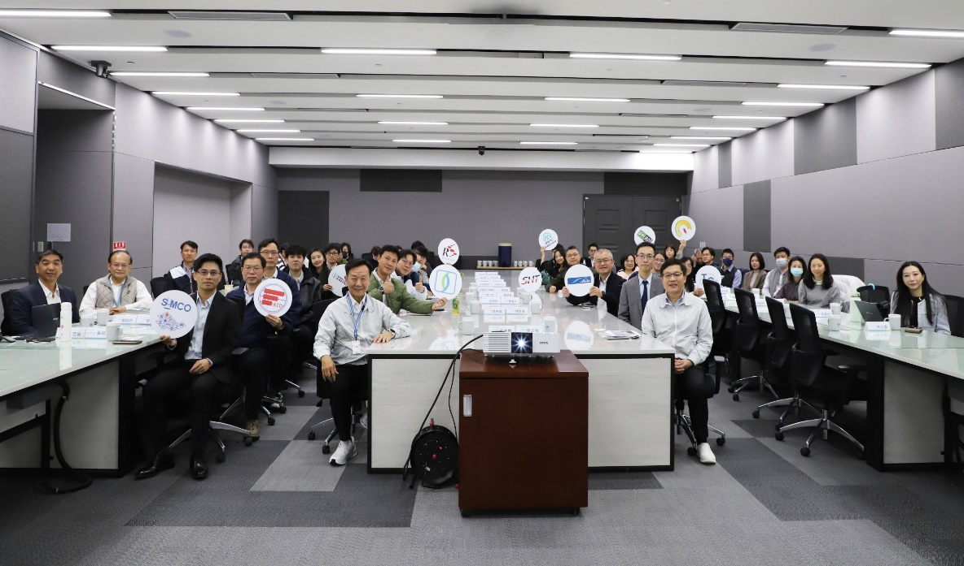
2025 Nature and Climate Synergy Supply Chain Workshop

Responsible Mineral Sourcing Management
Nanya Technology is committed to managing conflict-free minerals and implementing a responsible procurement strategy. We have also published a Responsible Mineral Sourcing Policy to align with the requirements for responsible metal procurement, uphold our responsibilities as part of the Responsible Business Alliance (RBA), and achieve the goals of the Responsible Minerals Assurance Process (RMAP). Since 2022, Nanya Technology has added the statement "Comply with RMI Policy and Conflict Mineral-Free" to its product labels, declaring that the company's products meet the mandate of the Responsible Minerals Initiative (RMI) and are free from conflict minerals. RMI Grievance Mechanism to implement responsible mineral procurement management, Nanya Technology has established a responsible mineral grievance channel for employees, suppliers, customers, and other stakeholders to raise concerns, complaints, or suggestions related to conflict minerals, cobalt, mica, and other responsible minerals. We will handle these matters carefully in accordance with relevant procedures and keep the complainant’s information confidential.
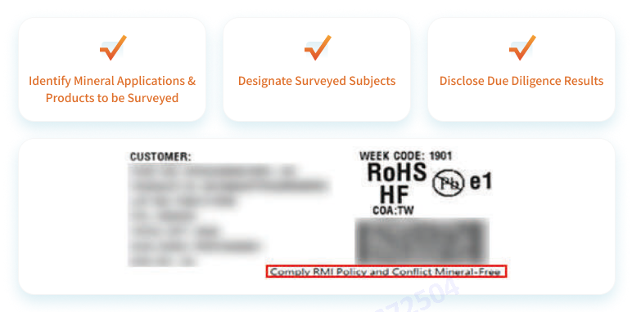

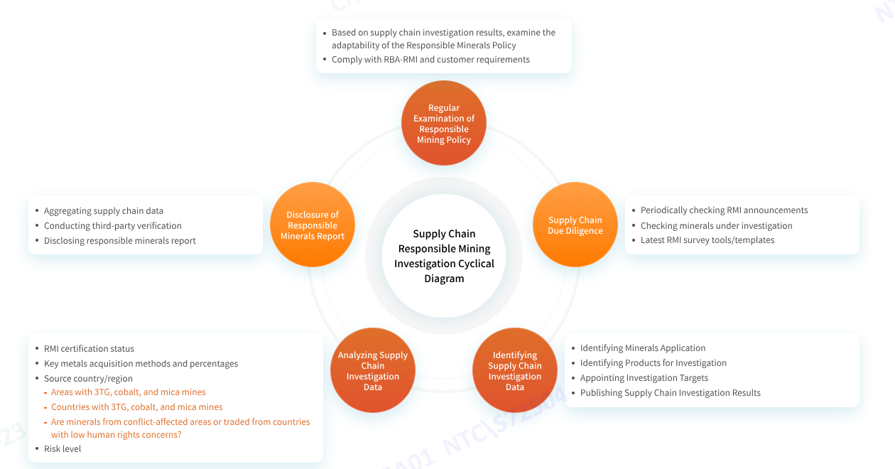

Result of Responsible Mineral Procurement Due Diligence
As a DRAM supplier, Nanya Technology conducted due diligence on its supply chain. After comparing its findings with the Responsible Minerals Initiative (RMI) qualified smelter list, 250 smelters or suppliers were identified in the 2025 supply chain investigation .Among them, 211 smelters or suppliers reported information concerning the gold, tantalum, tin, tungsten, cobalt, and mica currently used in our company's product supply chain. Approximately 46% (115) of these smelters reported that their mineral sources might originate from the Democratic Republic of Congo or adjoining countries, or from recycled/scrap metals. According to supply chain reports, these 115 smelters have all confirmed that their mineral sources comply with the Responsible Minerals Assurance Process (RMAP) policy requirements and have been approved as legitimate smelters by the Responsible Minerals Initiative (RMI).
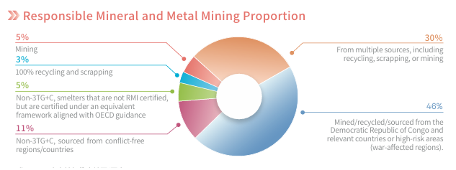
For more information, please read Responsible Procurement Chapter
閱讀全文
最新消息 | 粉絲專頁

